**CSCI 3260 Group 5 Report**

Xu Minxuan, 1155014330

Zhou Zhihao, 1155014412

2016-04-17

**Moving Objects:**

* Car (Zhou)
  + Random acceleration and deceleration behavior
  + New textures and car models

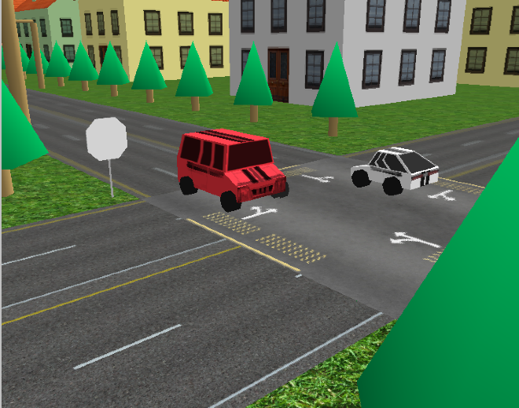

* Hot Air balloon (Xu)
  + Random floating behavior
  + Curved surface

(advanced feature)

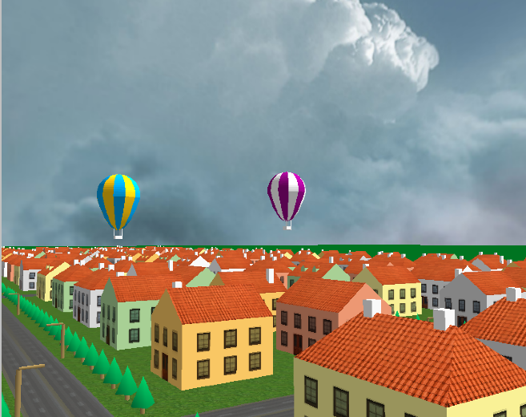

**Buildings & Scenarios:**

* Alexander Nevsky Church (Xu)

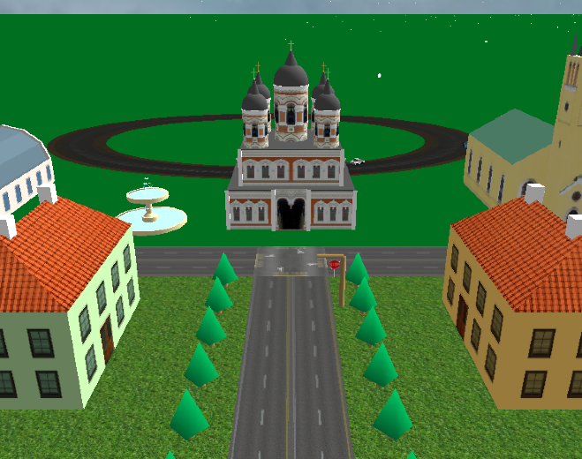

* St.Olav Church (Xu)

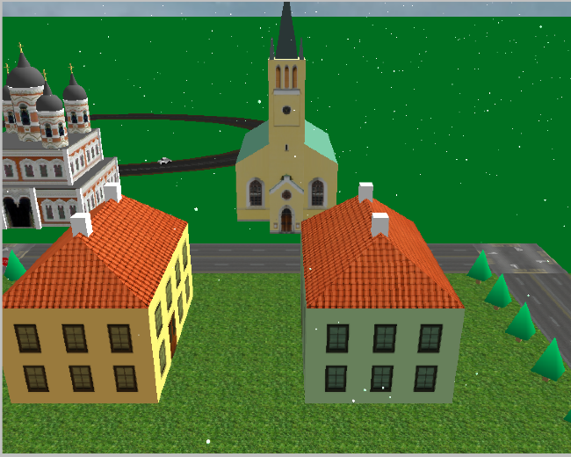

* Medieval Gate (Xu)

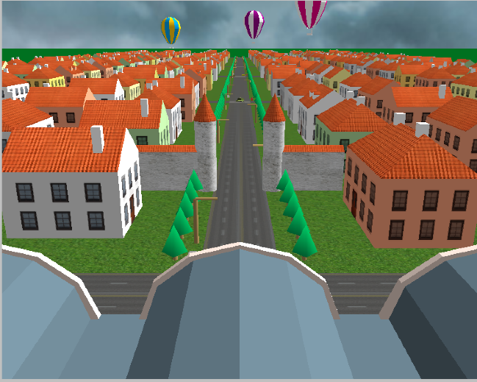

* Central Market (Xu)

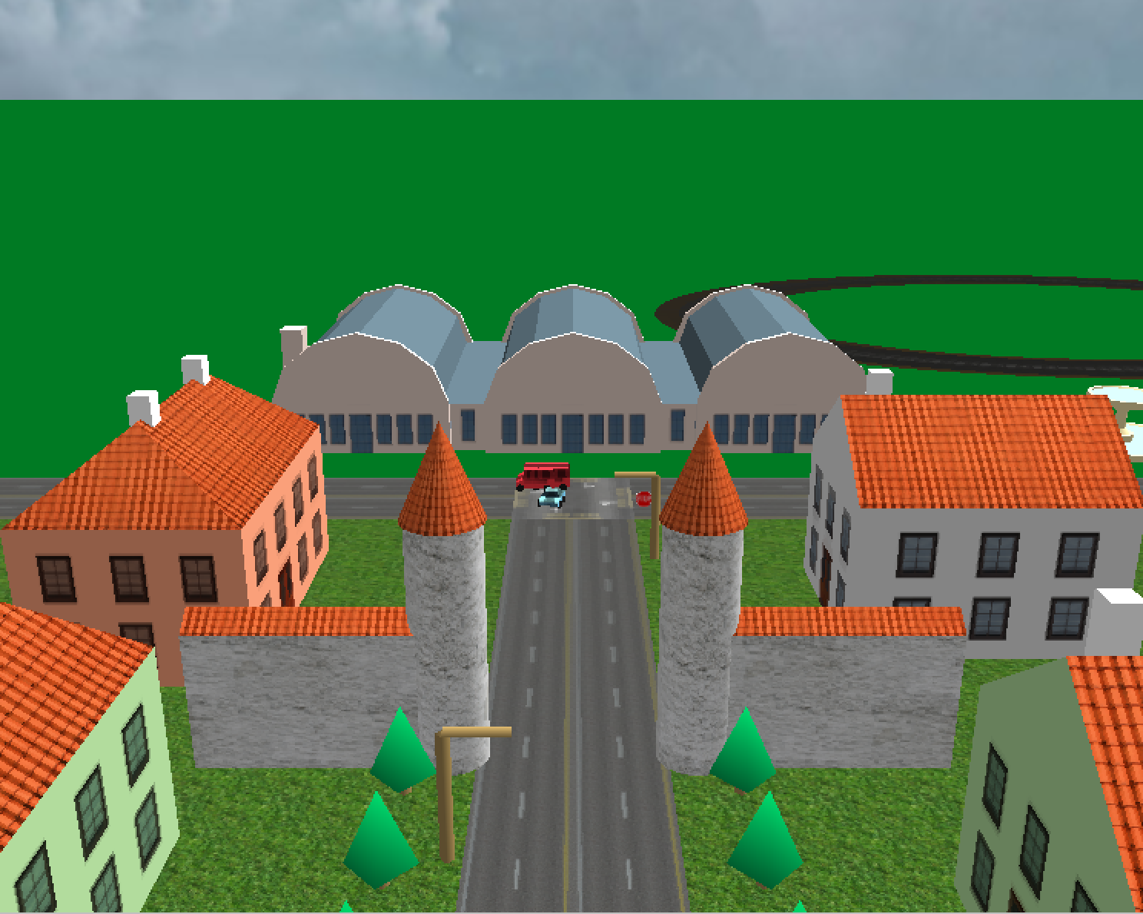

* Town Hall (Xu)

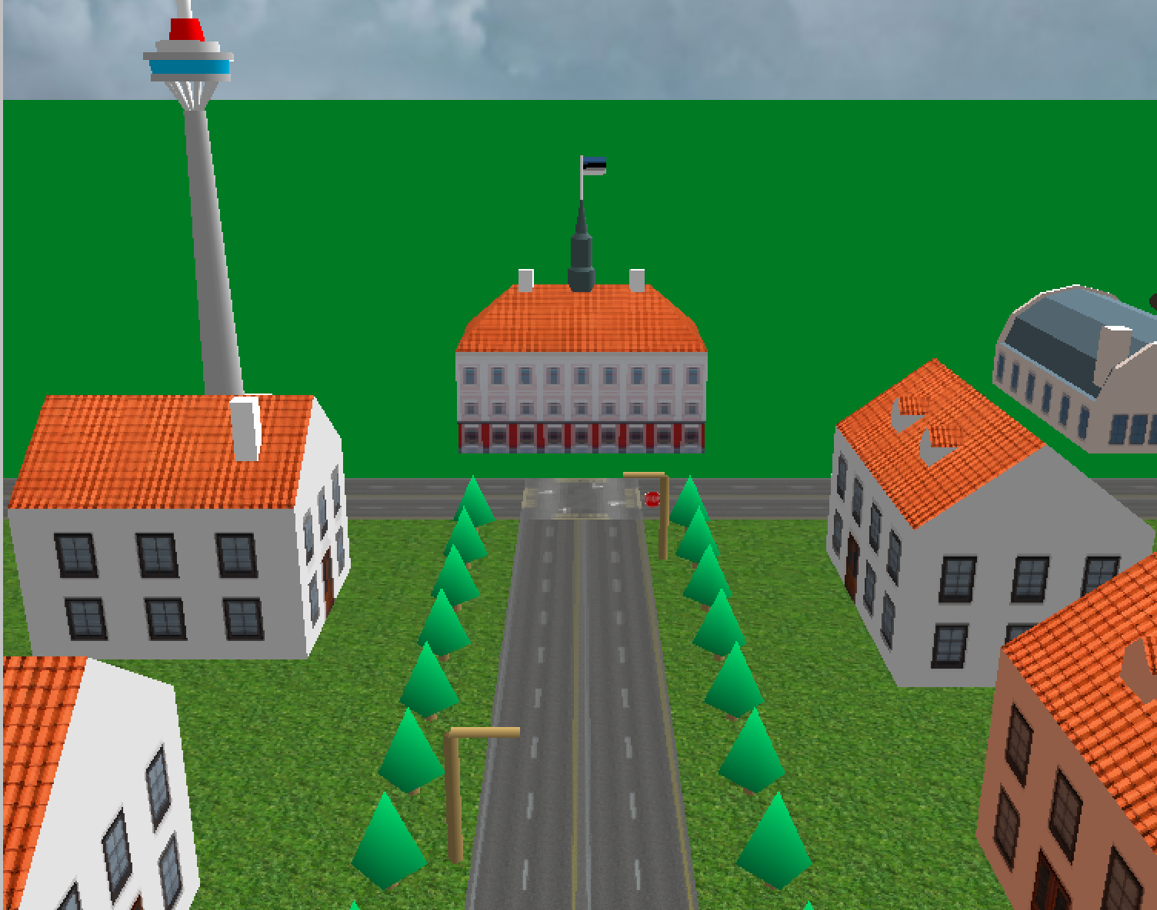

* Racing Track (Zhou)

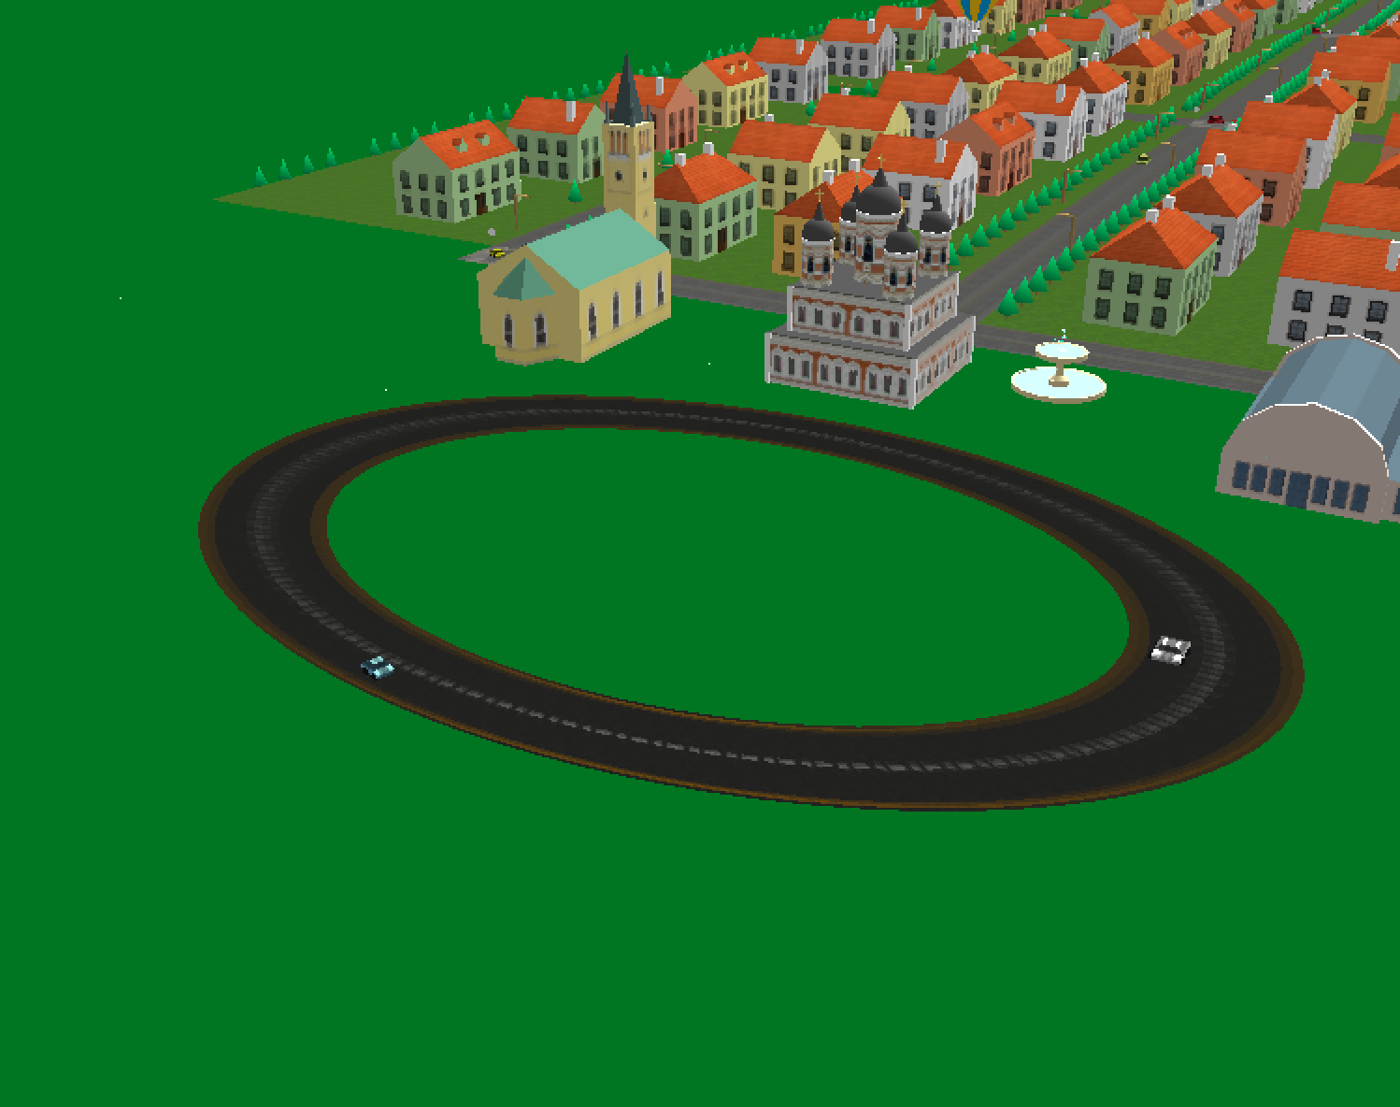

* Sauna House (Xu)
  + Multi-texturing (advanced feature)

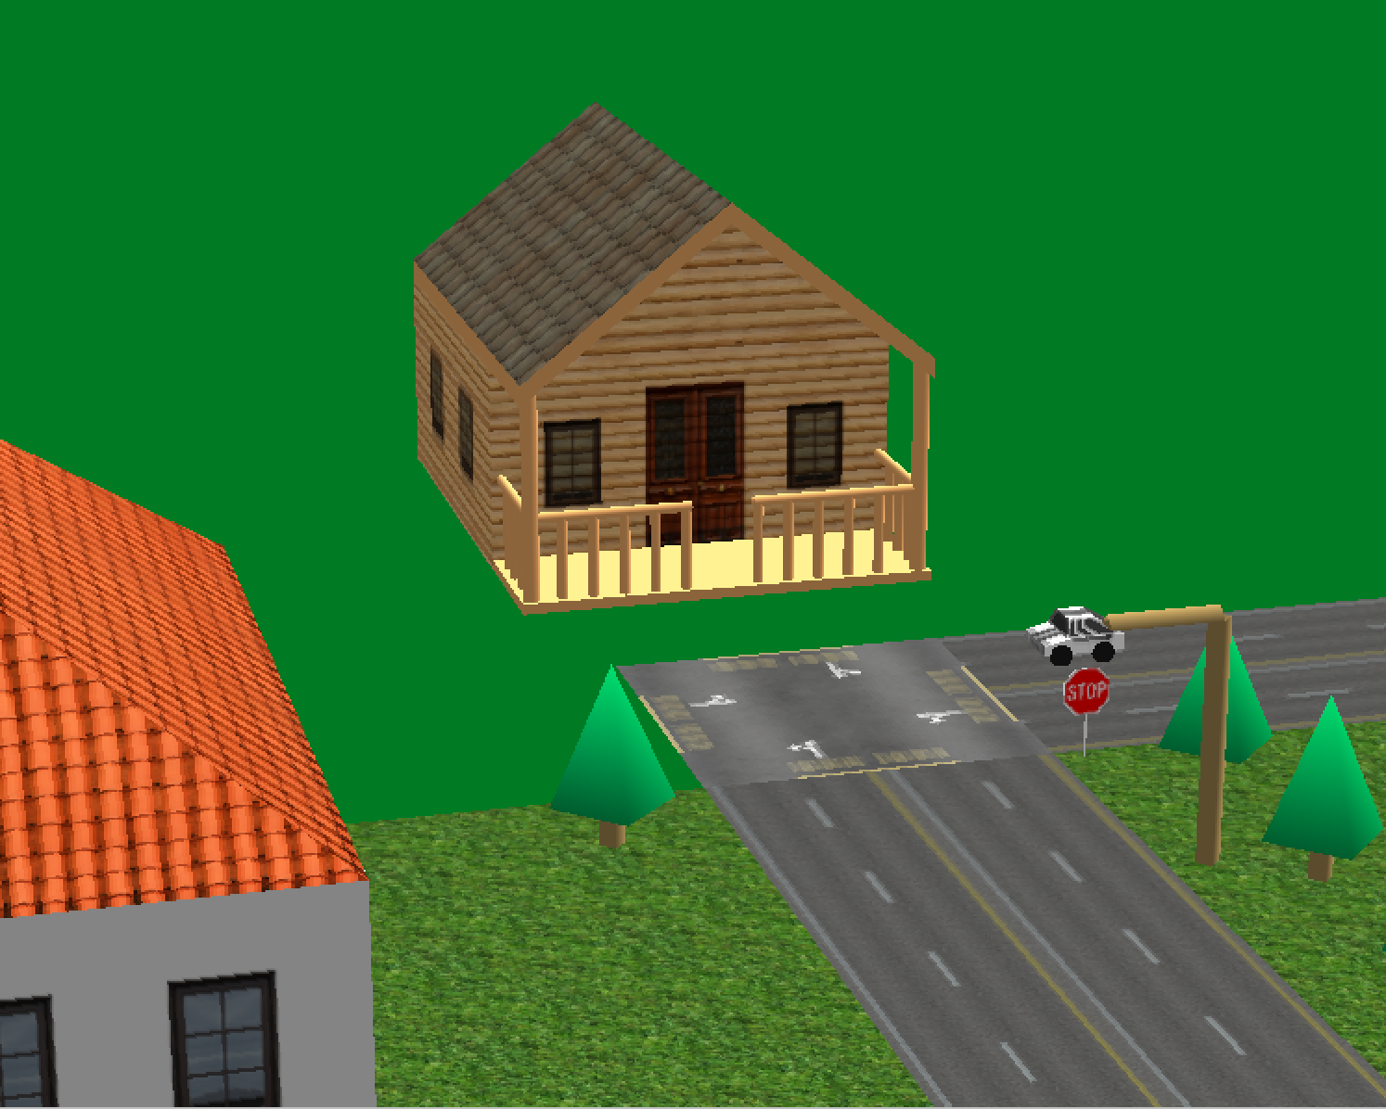

* TV Tower (Xu)
  + Changes with time

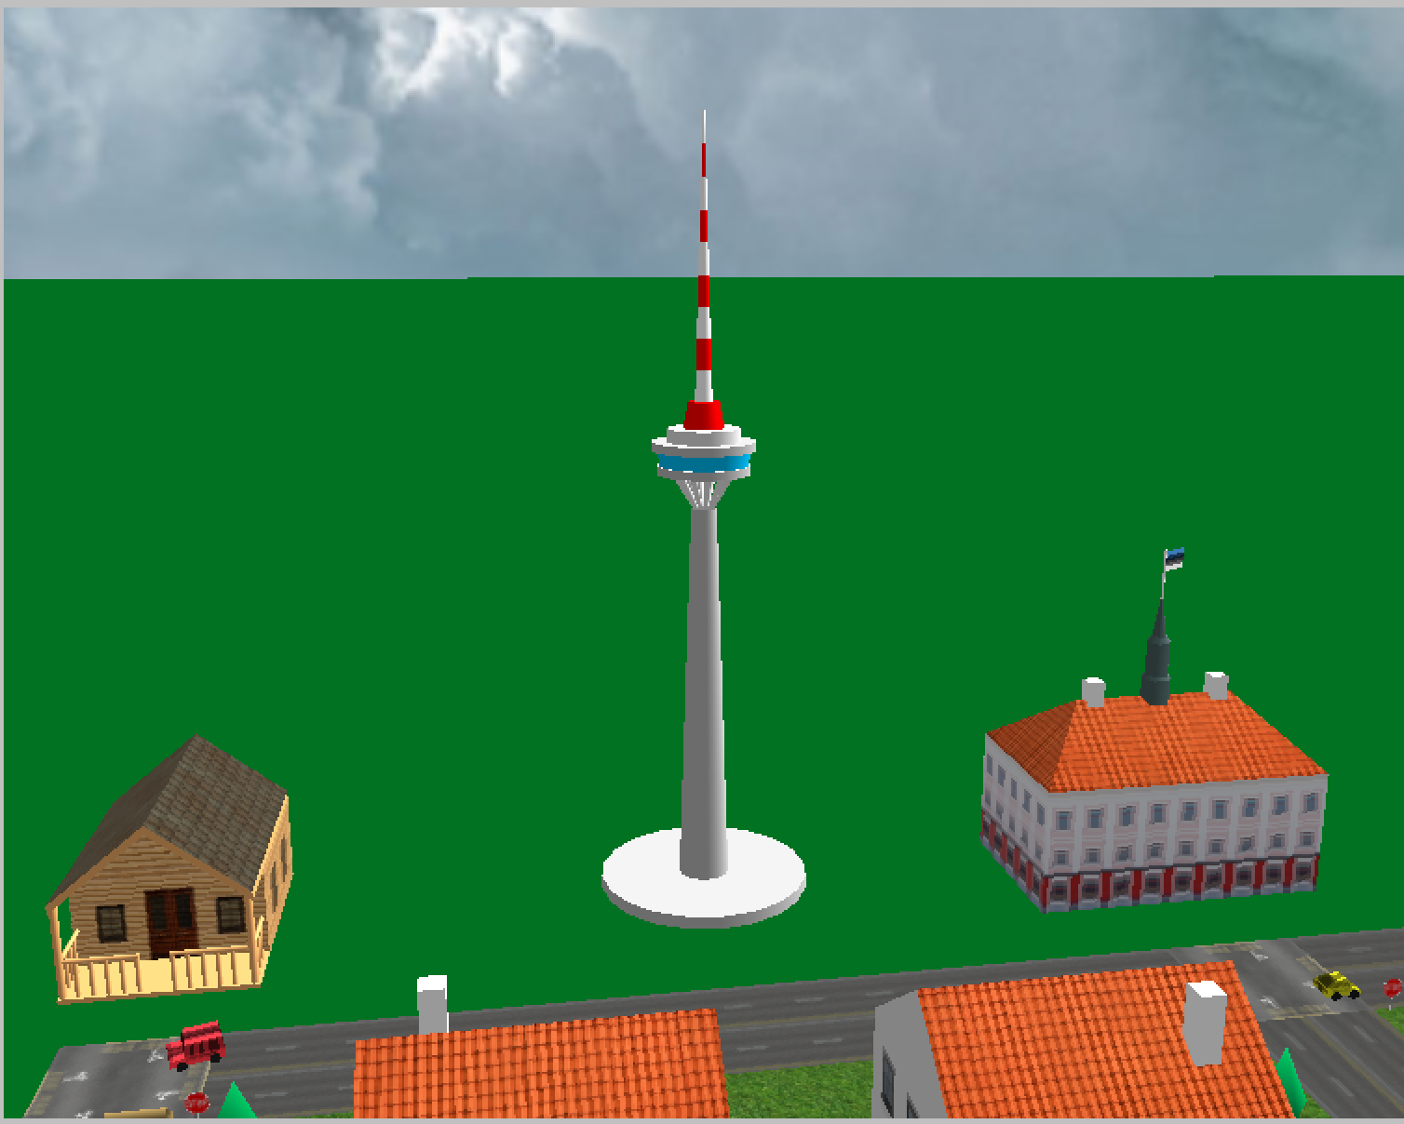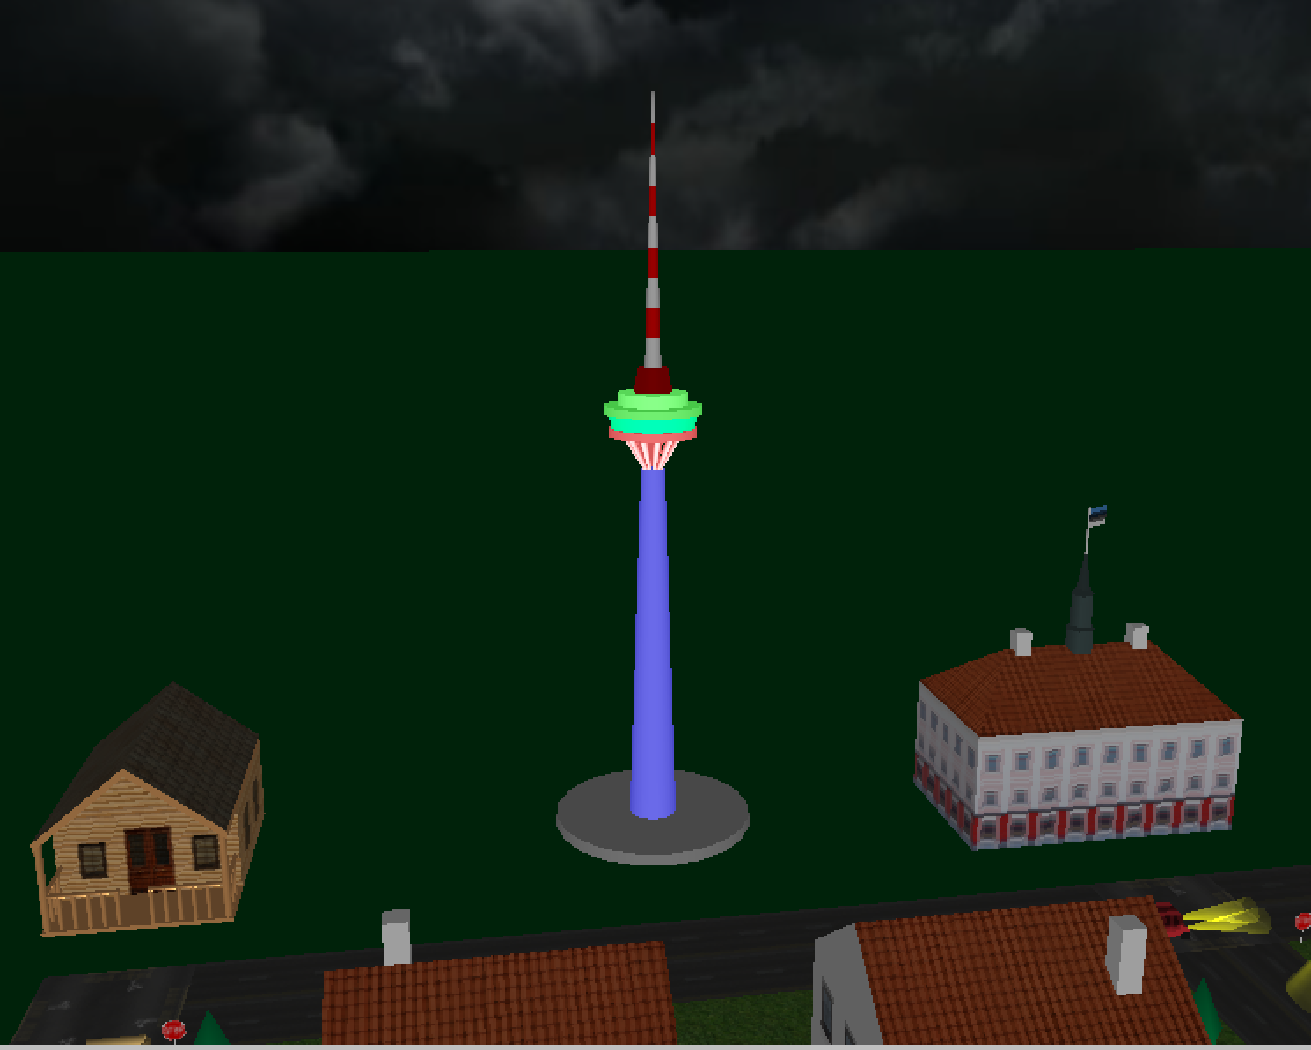

* Skybox (Zhou)
  + Changes with time

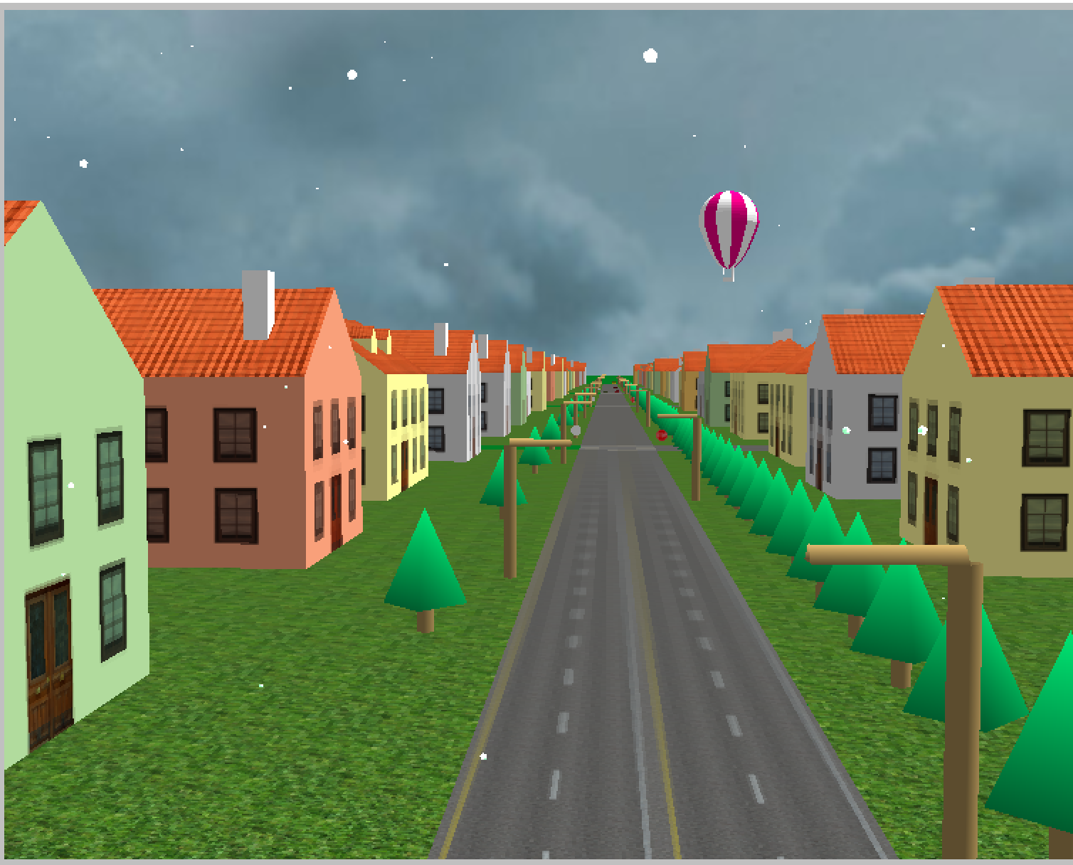

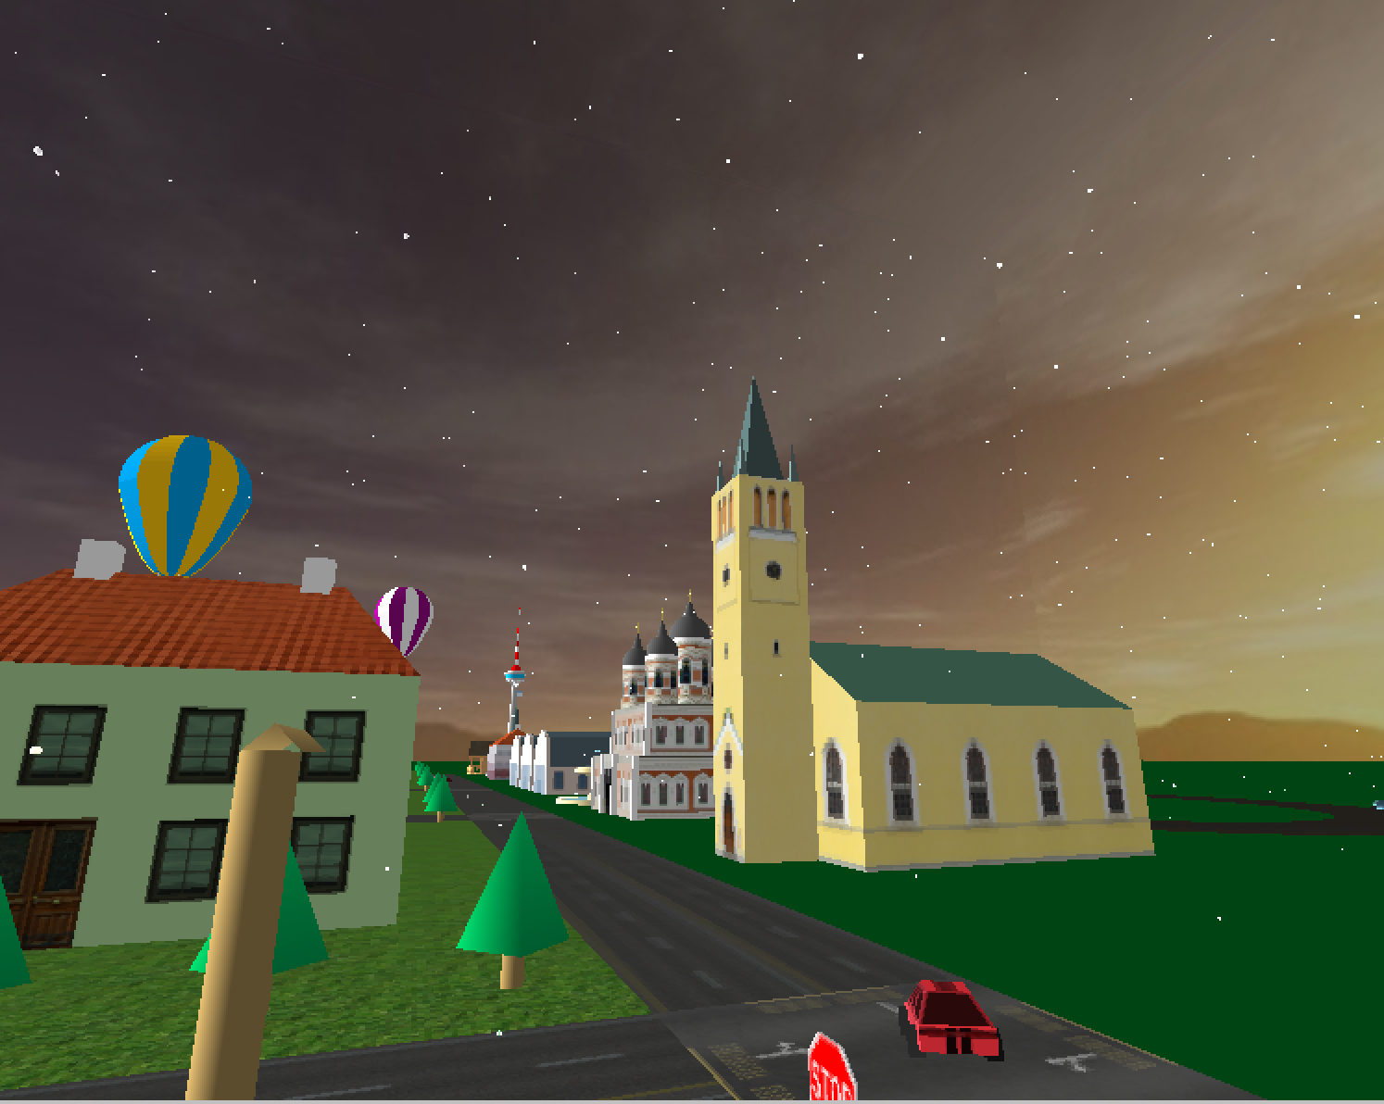

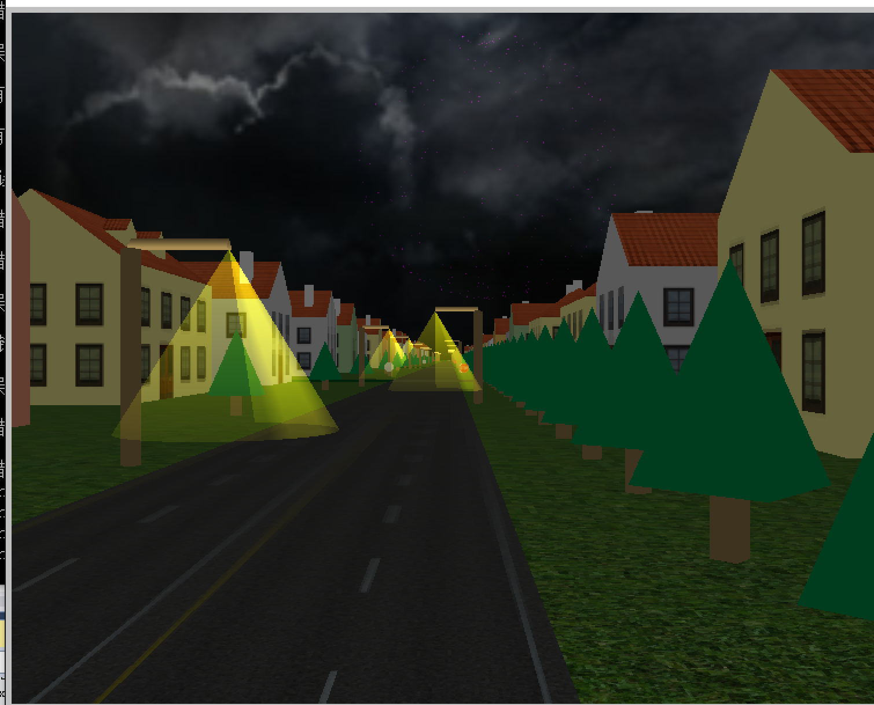

* Fountain (Zhou)
  + Particle system (advanced feature)

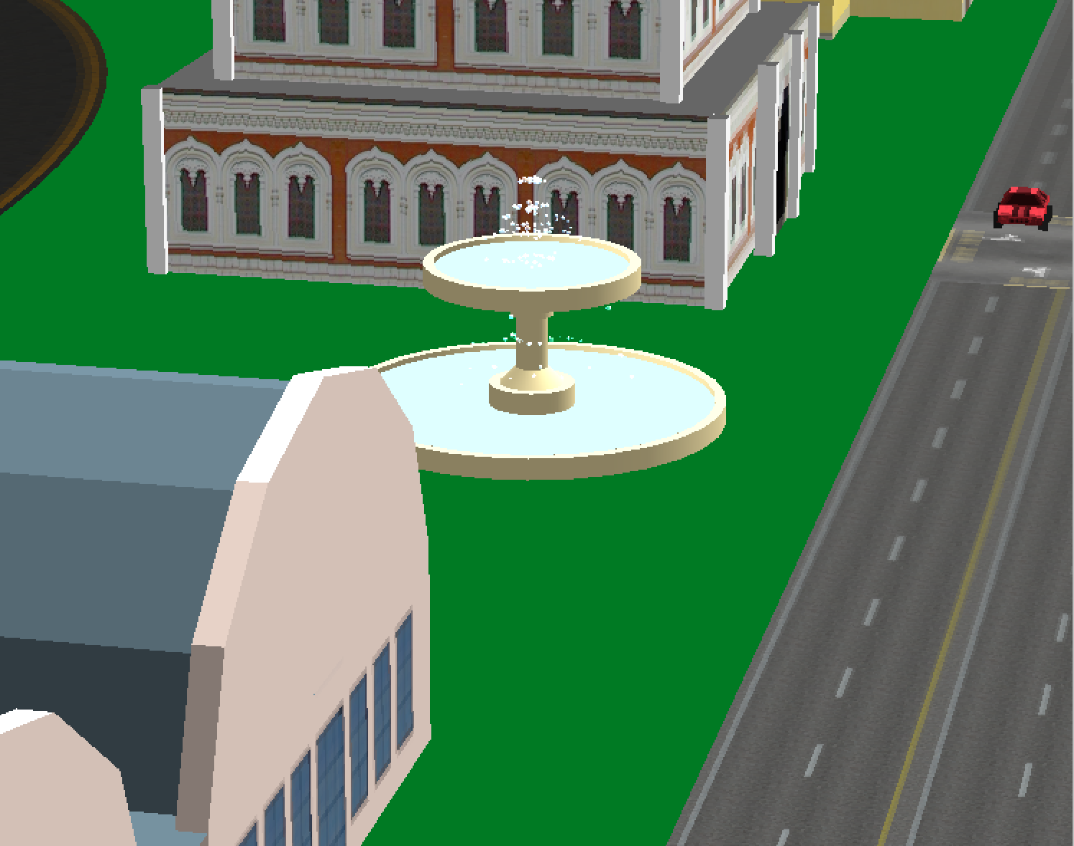

* Fireworks (Zhou)
  + Particle system (advance feature)

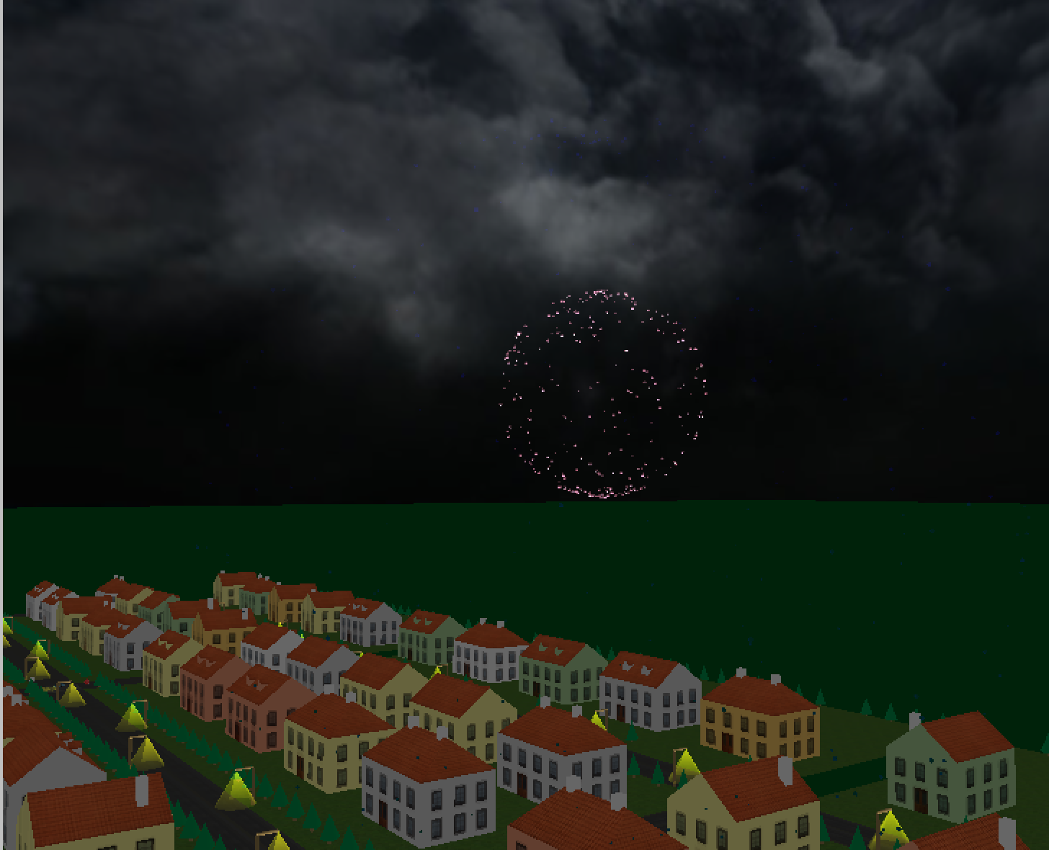

* Snow (Zhou)
  + Particle system (advance feature)

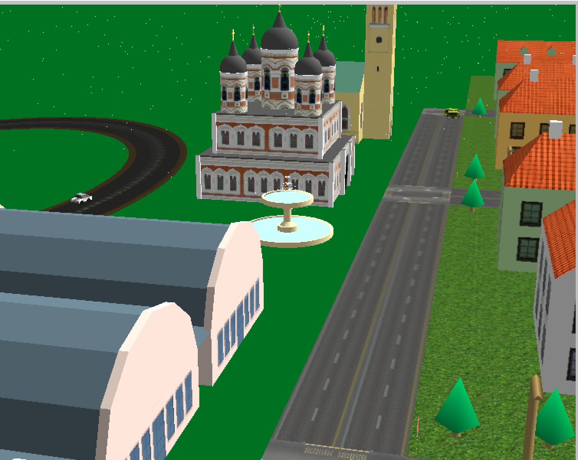

* House and Grass (Xu)
  + New house model and various new textures
* Roads and Intersections (Zhou)
  + New textures

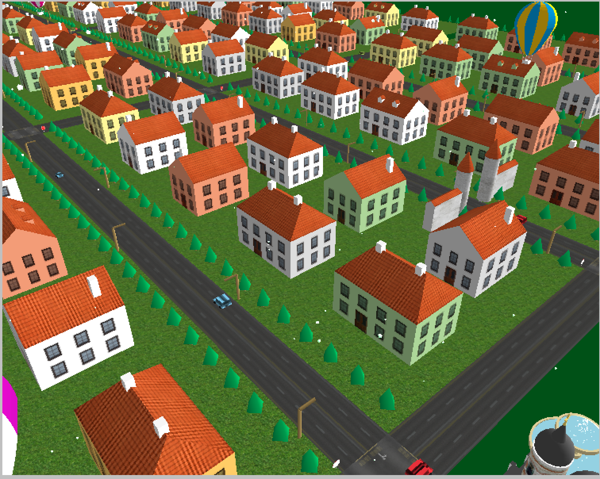

**Selected Views**

